**Preparation, Characterization of Ag2O/Cr2O3 and Investigation of The Photocatalytic Degradability on Congo Red textile dye**

Mohammed Zuheir Hassan, Assist. Prof. Dr. Nada Yehya Fairouz

Hilla, Babylon, Iraq

Corresponding author : mohaalnajafy89@yahoo.com

**Abstract:**

A new photo catalyst (Ag2O/Cr2O3) was prepared by using of the co-precipitation method by mixing two different metal nitrate include of chromium(III) nitrate [Cr(NO3)3.9H2O] with silver nitrate AgNO3 in different values and was calcinated in three different temperatures (400°C, 500°C & 700°C ), and then its effectiveness for the photocatalytic activity for the degradation of Congo red as a textile dye was done to optimize the best photocatalyst and was found that (Cat-3C-) was the best for the photodegradation of Congo red, and with removal percentage (69.35%) when the concentration of Congo red was (40 ppm) with weight of catalyst (0.15 g) at room temperature. The characterization of the prepared catalysts had been carried out by the XRD & SEM and has been found that the appointed catalyst (Ag2O/Cr2O3) was successfully prepared. And then some studies had been performed to optimize the reaction effective parameters on the photocatalytic degradation of Congo red such as: catalyst weight, initial concentration of the dye solution. The best catalyst's weight was (0.07g) and the concentration of the dye was (10ppm).

**Keywords:** Heterogeneousphotocatalytic, chromium (III) nitrate, silver nitrate, Ag2O/Cr2O3, Congo red, XRD and SEM.

**الخـــــــــــــــــــلاصــة:**

تم تحضير العامل المساعد الجديد (Ag2O/Cr2O3) عن طريق استخدام طريقة الترسيب المشارك بواسطة مزج نترات لفلزين مختلفين وهما نترات الكروم الثلاثية تساعية الماء مع نترات الفضة وبنسب مختلفة وتم تحميصها في ثلاث درجات حرارة مختلفة (400°م و500°م و 700°م), ومن ثم تم تعيين فعاليتها في التحفيز الضوئي في تكسير صبغة الكونغو الأحمر التي هو من الاصباغ النسيجية ,اذ تم تعيين العامل المساعد الافضل في التحفيز الضوئي الذي هو (Cat-3C-) حيث أعطى نسبة إزالة للصبغة (69.35%) عندما يكون الكونغو الأحمر (40ppm) ووزن العامل المساعد (50.1 غم) عند درجة حرارة الغرفة. تم تشخيص العوامل المساعدة المحضرة بواسطة جهاز حيود الاشعة السينية (XRD) و مجهر المسح الالكتروني (SEM)حيث تم التأكد من تحضير العامل المساعد بنجاح. وكتطبيق لفعالية العامل المساعد المحضر تم اجراء بعض الدراسات لتحديد العوامل المؤثرة على كفاءة التكسير الضوئي المحفز للكونغو الأحمر مثل :تــــأثير وزن العامل وكذلك التركيز الابتدائي لمحلول الصبغة: اذ أن افضل وزن للعامل المساعد هو (0.07 غم) الذي أعطى أفضل نسبة تكسير لصبغة الكونغو الأحمر بتركيز (10ppm).

**Introduction:**

One of the biggest troubles that facing our countries in the last centuries is water pollution especially by the wastes of the industrial wastewater because it is high soluble in water and need for many hours and days unless need for many years to be degraded by the sunlight alone. So the advanced oxidation processes (AOPs) are used to remediate this problem and the heterogeneous photocatalytic process is one of the most important method used to damage these organic and inorganic wastes [Lee (2008), Bibek (2010) and Harikumar *et al.* (2013), Miguel (2003)].

When someone thinking about the wastewater treatment, in the beginning he has to think about both the feasibility of the treatment and consideration of the economics sides of the process. There are different types of techniques available to the remediation of the organic contaminants in the wastewater such as chemical, physical, physicochemical and biological processes [Heponiemi, A. & Lassi, U.(2012)].

Heterogeneous photocatalytic processes can be easy understood , and that is due to its definition as the employing under irradiation of steady solid semiconductor (such as TiO2) for stimulating a reaction of the solid/solution interface [Galvez, J. B. and Rodriguez, S. M., (2003)], It is impressive to know how the photocatalytic processes work, when the incident light (hν) energy by a UV-lamp on a semiconductor is been equal to or higher than the band gap energy of the semiconductor it will excite the electron from the valence band(VB) which is full of electrons at zero Kelvin to the conduction band (CB) which is empty at the zero Kelvin, left a hole in the valence band and that what is called excitons (**e-/h+**) then the generated electron and hole transfer to the surface of the semiconductor, where the semiconductor acts in two types of reactions, acts as a donor for electrons when the promoted electron enter in reduction reaction with the species on the surface, while it acts as an acceptor for electron when the positive hole participates in an oxidation reaction [Nicholas (2010) & Falah H. (2011)] Figure-1-.

**Mechanisms of releasing oxidizing species:**

The heterogeneous process was a very complicated process because the oxidizing pathway wasn't very clear until Jean-Marie Herrmann suggested that the heterogeneous process can be divided into five steps [Herrmann, (1999)]:

1. Transferring of reactants to the surface.
2. Adsorption of one of the reactants.
3. Reactions of the reactants in the adsorbed phase.
4. Desorption of the product(s).
5. Diffusion of the product(s) from the surface.

The hydroxyl radicals can be formed by two pathways, the hole in the valence band (hVb+) can either react with the adsorbed water or the surface hydroxide ions (OH-) groups on the surface of catalyst such as titanium dioxide (TiO2) particles [Radwan A. (2005), Lomoră M. *et al.* (2011), Cheng C. *et al*. (2012)]:



(1)



(2)

(3)

Generally, as acceptor molecules (A) such as O2 will be adsorbed and react with an electron in the conduction band, while donor molecules (D) such as water (H2O) will be adsorbed as well and react with a hole in the valence band [Lomoră M. *et al.* (2011), Cheng C. *et al*. (2012)], as the following equations:



(4)

(5)

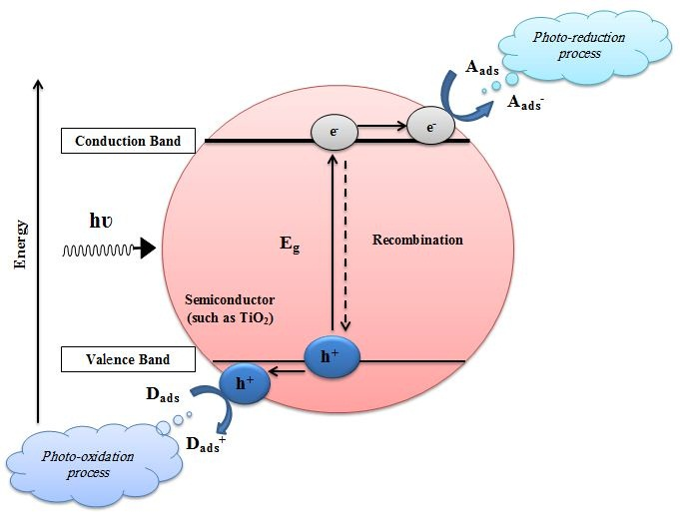

**Figure-1- the simplified photocatalytic process on TiO2 surface.**

The advantages of heterogeneous systems are [Sathish M. (2006)]:

1. Simplicity of separation of catalyst after reaction by centrifuge.
2. Availability of large surface area.
3. Low cost.
4. Stability (no chemical reaction).

In the heterogeneous photocatalytic process not all the semiconductors have high photoactivity, because of the recombination process that occurred between the photohole and photoelectron, so one of the most important remediation methods is the doping of metal on the surface of the semiconductor, the activity can be increased by adding a noble metal or a metal from the transitional series of the periodic table. The metal doped on the surface of the semiconductor acts as a capture for the released electrons by the exerted UV light on the photocatalyst [Julian G. *et al.* (2003), Dingwang C. *et al.* (2001), Sakthivel *et al.* (2004)], the electron migrated to the conduction band and then trapped by the metal to avoid the recombination process, while the hole migrates to the surface of the photocatalyst and participates in an oxidation process with the adsorbed water of other organic compounds as the schematic figure(2).

As an example for the metal doped a semiconductor Ag/TiO2 and Pt/TiO2 (prepared by the photoreduction deposition process and the chemical vapor deposition "CVD") [Chia-H. (2007)].

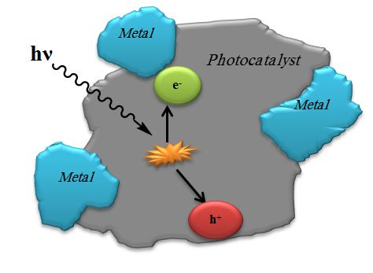

**Figure-2- Metal deposition on the surface of the semiconductor and the process of trapping the electron by the metal**.

**Congo red:**

Congo red dye was first synthesized in 1883 by Paul Bottiger who was working then for the Friedrich Bayer company in Elberfeld, Germany. Congo red is considered a pH indicator because it changes of color from blue to red at pH(3.0-5.2) [Bibek (2010)]. Congo red is the sodium salt 3,3’-([1,1’-biphenyl]-4,4’-diyl)bis(4-aminonaphthalene-1-sulfonic acid), its formula is (C32H22N6Na2O6S2) and its molecular weight is (696.66 g/mole) and it is considered a secondary diazo dye because it contains two azo groups (-N=N-) figure-4-, it absorbs the electromagnetic spectrum at λmax=497nm [Pooja M. et al. (2013)].

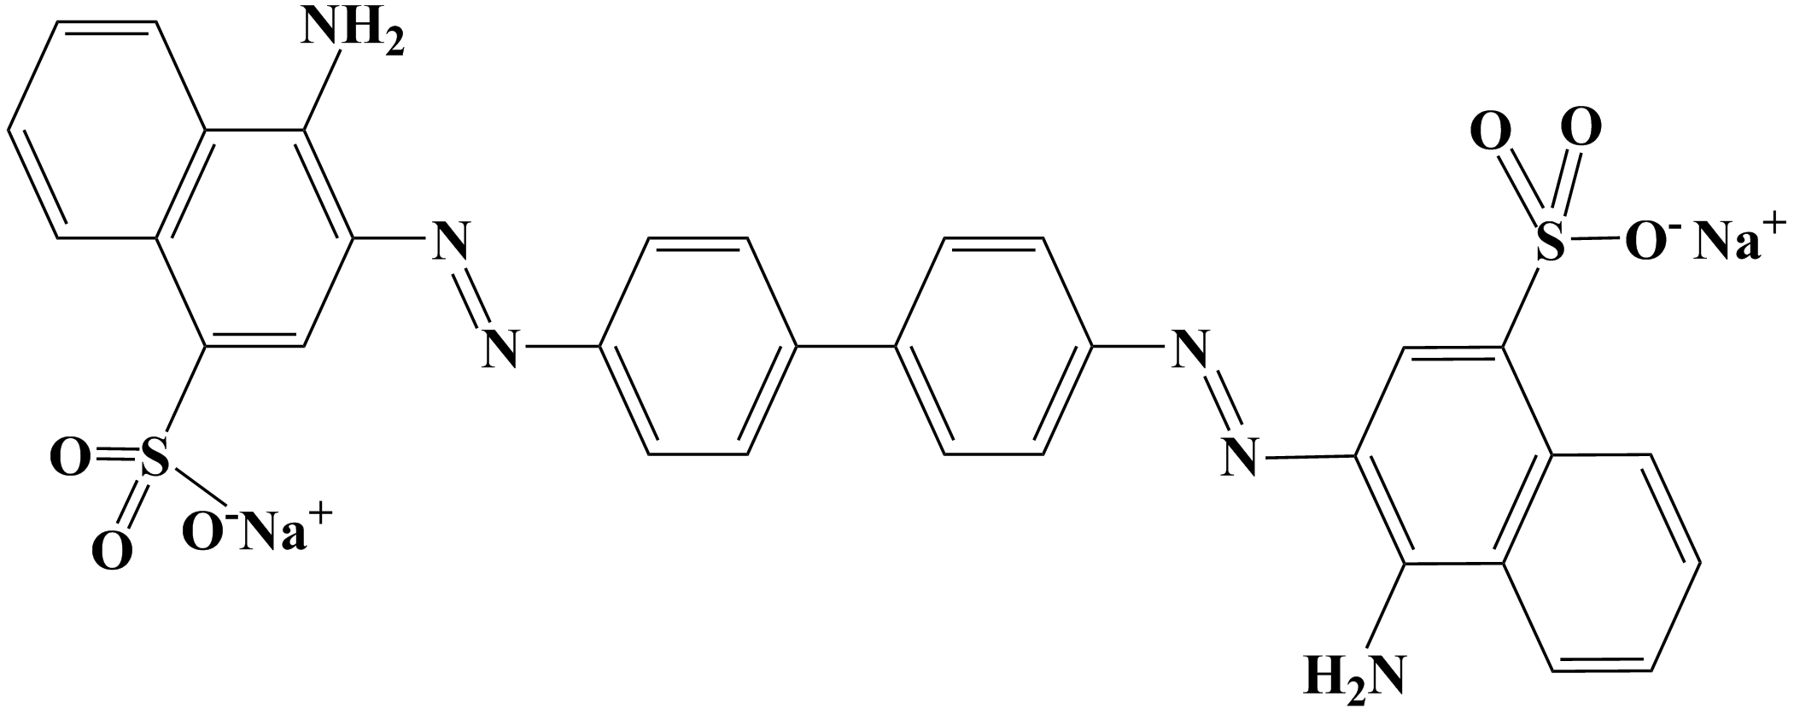

**Figure-3- The structure of Congo red.**

Lanping Zhang *et al.* (1997) prepared chromium oxide films on Pt(111) with thickness ranging from less than monolayer to more than eight monolayer, they found that chromium oxide grows with two different type structures on the Pt(111) surface depending on coverage and temperature.

Zorica V. *et al.* (2002) activate by mechanically state for an equimolar of ZnO and Cr2O3 powder mixture by grinding using a high vibrational grinder for 0-180 min, and found that the activity of powders increases with increasing the grinding time and this is an indicator for the activity of spinels increase with decreasing of the grain size of the powdered spinel.

Shahid Khan Durrani *et al.* (2012) synthesized some transition nanosized metal chromite spinels by using hydrothermal process and made a characterization by XRD, SEM and thermogravity technique. And found that nanocrystalline transition metal chromite spinels such as CoCr2O4 (bluish-green), MnCr2O4 (grayish-green), Cu0*.*5Mn0*.*5Cr2O4 (green), NiCr2O4 (sage green), CuCr2O4 (blackish-green), and Ni0*.*8Cu0*.*2Cr2O4 (dark green) were synthesized successfully through a hydrothermal method.

**Materials and methods**

silver nitrate AgNO3 and Chromium(III) nitrate nonahydrate [Cr(NO3)3.9H2O] (Hopkin & Williams).

Ag2O/Cr2O3 was prepared by Co-precipitation method [Prasad R. et al. (2010)], different percentages of AgNO3 silver nitrate and Chromium nitrate nonahydrate Cr(NO3)3.9H2O were taken table-1-, dissolved in distilled water and were mixed together and transferred to a beaker (400ml) and filled to the mark with distilled water put on a hot plate magnetic stirrer. The temperature was fixed about (65oC-75oC) with continuous stirrer, NaOH (8N) drop-wise was added to the mixture and the pH maintained by a pH meter at (7.5-9.5), then the obtained precipitate was left on the hot plate for 1 hour with continuous stirrer.

**Table-1- Number of moles and percentages of AgNO3 and Cr (NO3)3.9H2O that was taken to prepare the catalyst.**

|  |  |  |  |  |
| --- | --- | --- | --- | --- |
| Name of photo- catalyst | AgNO3 % | Cr2(NO3)3.9H2O % | No. of moles of AgNO3 | No. of moles of Cr2(NO3)3.9H2O |
| Cat-1- | 80 | 20 | 0.08 | 0.02 |
| Cat-2- | 60 | 40 | 0.06 | 0.04 |
| Cat-3- | 40 | 60 | 0.04 | 0.06 |
| Cat-4- | 20 | 80 | 0.02 | 0.08 |

The obtained precipitate was washed with a hot distilled water for many times in order to eliminate the undesired sodium ions, until pH of obtained washing water close to the neutral medium (pH=7.0) it means that the precipitate is free of sodium ions, and the precipitate was dried in an oven at about (100oC) then the precipitate was triturated in a ceramic mortar to make homogenous particle Figure-4-.

The last step was calcination of the precipitate in different temperatures (a)400oC (b)500oC and (c)700oC for 4 hours. The obtained precipitates was (green-brown) color and was characterized by X-ray diffraction (XRD) and Scanning electron microscope (SEM).

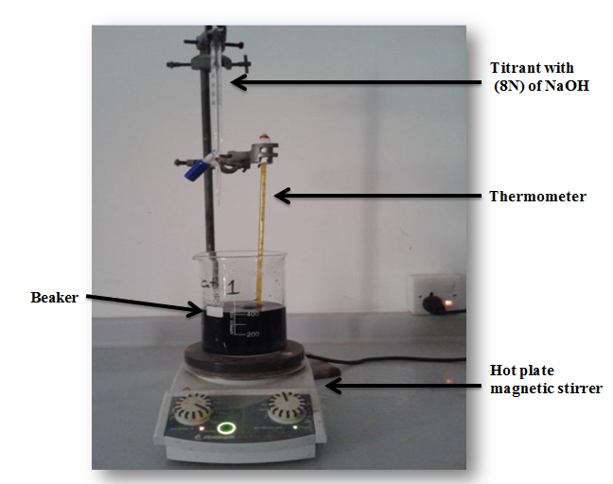

**Figure-4- Co-precipitation reactor.**

**Characterization process:**

In this work, the prepared catalysts characterized by using XRD (Rigaku- MiniFlex II Desktop X-ray Diffractometer) and the crystallite size was determined from Scherrer's equation eq.-6-, where it was prepared as a homogenous powder, (1 g) of the catalyst was placed on a slide put in front of the path of the X-ray.

$D=\frac{kλ}{βCosθ}$*………*(6)

Where D is mean crystalline size, k is the Scherrer's Constant or that which is called the shape factor because it depends on the shape of the crystal and its value is (0.94), λ is wavelength of the X-ray radiation (0.15406 nm for Cukα), β is the full width of half-maximum (FWHM) intensity of the appeared peak explained in radians (Actually, β is measured in degrees but to unitizing the units of the equation β multiple by (π/180) to transmute to the radians and lastly θ is the diffraction Bragg's angle [Riahi-Noori N. et al. (2011)].

Scanning electron microscope(SEM) [INSPECT S50] was used to determine the morphology of the prepared photocatalyst and the crystallography, a bit weight of the catalyst was taken and coated with a thin carbon layer and fixed on a plate and exposed to an electron beam.

**Calibration curve:**

A solution of Congo red was prepared with a concentration (1000 ppm) in a volumetric flask with (1.0 Liter ) volume then series of solutions were prepared with different concentrations (1, 3, 5, 7, 10, 15, 20 and 25ppm) and then measured by the UV-Visible spectrophotometer [UV-1650PC Shimadzu, Japan] and then the spectrum and the calibration curve were drawn.

**Applications of the prepared photocatalysts:**

Many applications for the prepared photocatalysts were carried out to determine the optimum conditions for photocatalytic degradation of Congo red as a textile dye, by using high pressure mercury lamp (125 watts), with light intensity (7.1 mW/cm2) at (5cm) distance between lamp and the photocell.

**Examination of the photocatalytic activity:**

The examining of the photocatalytic activity of the prepared Ag2O/Cr2O3 was made, a (0.15g) of the different prepared photocatalysts was taken with (100ml) of (40ppm) of Congo red, and put in the photoreactor at (298 K) and (7.1mW/cm2) light intensity at pH=7

**Determination of the adsorption time:**

To begin the study of the optimum conditions, at the beginning we have to determine the adsorption time of the photocatalysts to insure that most of dye molecules are adsorbed on the surface of the photocatalyst, so for the most active photocatalyst of prepared Ag2O/Cr2O3 (0.07g) was taken with (100ml) of (10ppm) of Congo red at (298K) and (7.1mW/cm2).

**Effect of catalyst's weight on the photocatalytic degradation of Congo red:**

This process occurred by making many experiments by using different weights of the photocatalyst (0.03, 0.05, 0.07, 0.1 and 0.25g) respectively, one experiment for each weight alone, then different weights of Ag2O/Cr2O3 were added to (100ml) of Congo red, here is all the other conditions were kept constant such as concentration of Congo red was (10ppm), temperature was (298K), pH=7, light intensity was (7.1mW/cm2).

**Effect of concentration of Congo red with constant weight of Ag2O/Cr2O3:**

Different concentrations of Congo red were taken in different experiments (10, 15, 20 and 25ppm) with (0.07g) of Ag2O/Cr2O3 in (100ml) of the dye at (298K), (7.1mW/cm2) was the light intensity and pH=7.

**Results and Discussion:**

**X-ray diffraction of Ag2O/Cr2O3 prepared at different ratios of Ag2O:Cr2O3** **and comparison to the metallic Ag2O and Cr2O3:**

X-ray diffraction was taken for the prepared photocatalysts that were prepared at different ratios and were calcinated at (700oC) in figure-5-:

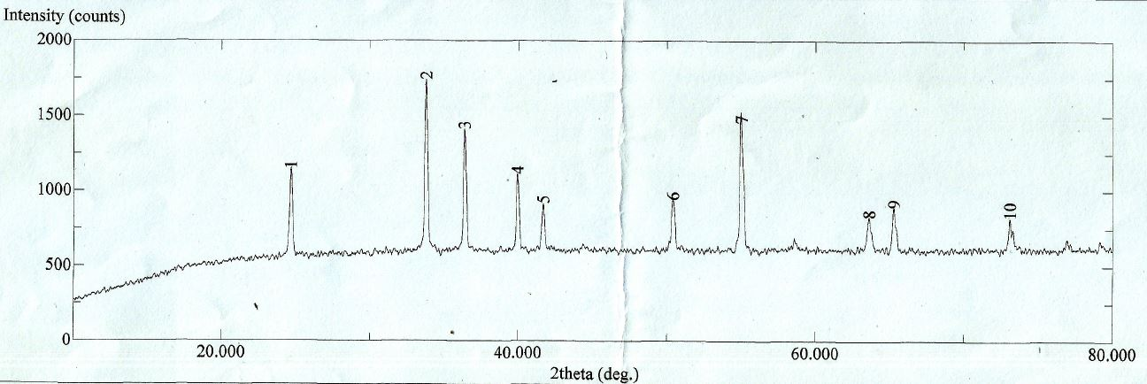

**Cr2O3-std.-**

**Figure-5-: XRD patterns of Ag2O/Cr2O3 prepared in different percentages and calcinated in (700oC) and compared to Cr2O3.**

Figure-5- is an obvious evidence for the good interface and constitution of Ag2O/Cr2O3 comixed semiconductor and showed the existence of the Cr2O3 peaks and the peaks of silver oxide (Ag2O) and was a shift in the peaks positions and intensities noticed relative to the formation of a new phase of the semiconductor and is (Ag2O /Cr2O3) mixture of the silver oxide on the chromium oxide (Cr2O3) surface, for (Cat-1-) there were many peaks (38.1409° and 44.3242°) return to Ag2O and (31.1919°, 36.0784° and 39.9502°) return to the Cr2O3 with consulting of the intensities percentages of the appeared peaks in the XRD charts, (Cat-2-) was nearly the same for (Cat-1-), because it appears three peaks two peaks at (38.1584 ° and 44.3366 °, 64.4 °) for Ag2O alone and the third is for Cr2O3 standard peak at (36.0884°, 62.2119°,) as the strongest peaks, but there is very few shift in the peak's position Lin X, *al* (2014).

For (Cat-3-) it was the second most intense peak was the peak of the new phase Ag2O/Cr2O3 at (29.0479 °) with an intensity approach to (94%) and there were other peaks observed for chromium oxide phase at (36.1503 °, 39.6341°, 41.6710° & 62.2337°), that means that the phase of Ag2O was less number of peaks in the chart of the XRD as (38.3651° & 44.1322°) with an intensity percentages (3% and 11%) respectively, as Kalavathy Santhi et, al. found at (2014) when they synthesized Ag–Fe nanocrystalline alloy by pulsed electro deposition and was characterized by XRD and they found that the alloy had an apparent peaks at ≈ (38 ° & 64°) return to metallic Ag and at ≈(44 °) corresponded to Fe/Ag.

For the (Cat-4-) here is the peak of the new phase Ag2O-Cr2O3 was appeared at (28.9664°) but with less intensity percentage was (51%) and the other strongest peaks was for Cr2O3 phase were at (33.6330°, 36.0860°, & 39.9362°, 41.5158°), and it was one peak of Ag2O phase at (44.0356°) but with small intensity (7%), that was all to insure us that is with the decrease of the Ag2O percentage decreases the number of peaks and its attribute. And as an example Gyawali et, *al* (2013). that they synthesized Ag◦-PbMoO4 sonochemically and they found out that the increase in the Ag percentages it would gradually increasing the peak's intensities and also it will appear a new peaks returns to the metallic silver and grow up

**Calculations of the mean crystallite size of (Ag2O/Cr2O3):**

From the X-ray diffraction the mean crystallite size of the Ag2O doped Cr2O3 was calculated and the impact of Ag2O loaded on the crystallite weight:

**Table-2- Effect of Ag2O loaded on the mean crystallite size of the prepared photocatalyst (Ag2O/Cr2O3) at different ratios and calcinated at (400oC) for 4hrs:**

|  |  |  |  |  |
| --- | --- | --- | --- | --- |
| Catalyst | 2θ | FWHM | Mean crystallite size/nm | Average |
| Cat-1C- | **31.4200** | **0.2820** | **28.93** | **27.95** |
|  | **38.4200** | **0.3060** | **27.18** |  |
|  | **44.6000** | **0.3060** | **27.74** |  |
| Cat-3C- | **29.2000** | **0.4000** | **20.29** | **17.01** |
|  | **35.4800** | **0.4940** | **16.69** |  |
|  | **36.3000** | **0.5880** | **14.06** |  |
| Cat-4C- | **31.4600** | **0.4470** | **18.25** | **18.54** |
|  | **36.5000** | **0.4710** | **17.56** |  |
|  | **55.1400** | **0.4470** | **19.82** |  |
| Cr2O3 "Std." | **33.64** | **0.306** | **28.32** | **29.23** |
|  | **36.36** | **0.282** | **30.96** |  |
|  | **55.04** | **0.329** | **28.43** |  |

And the above results summarized in Figure-6-:

**Figure -6-: Effect of the Ag2O loaded on the chromium oxide on the mean crystallite size of the prepared Ag2O/Cr2O3 at different ratios and calcinated at (400oC) and compared to Cr2O3.**

The above figure -6- and the table showed that the increase in the ratio of silver oxide loaded on the Cr2O3, it will decrease the mean crystallite size until the ratio became (20:80)% of (Ag2O:Cr2O3)% it will relatively increase, because of the crystallite size of the silver oxide is smaller than that of Chromium oxide.

**Scanning Electron Microscope (SEM):**

This technique was used to study the structures of the prepared photocatalysts from the aspect of the morphology of crystals of the semiconductors using the SEM's tip of the electron gun, the prepared photocatalysts Ag2O/Cr2O3 were compared with the standard materials (Ag2O & Cr2O3):

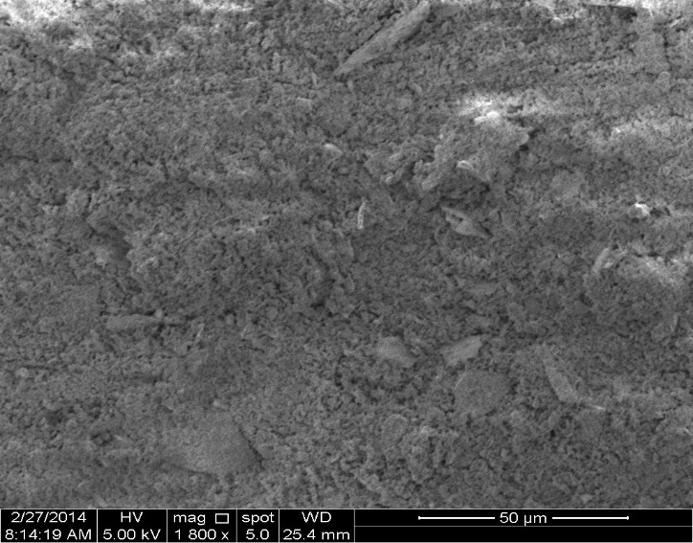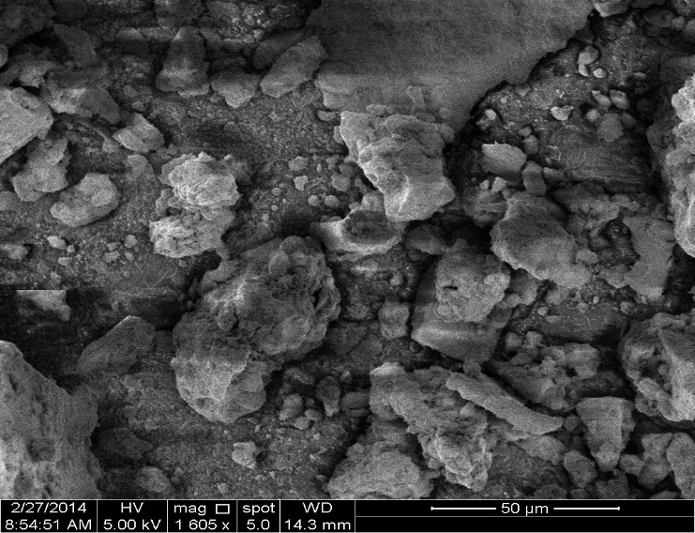

**(b)**

**(a)**

**Figure-7-: SEM of (a)Ag2O-Cr2O3 (40:60)% calcinated in 400oC (b) Cr2O**3.

a comparison was made, so the prepared Ag2O/Cr2O3 was more rigidity than the Cr2O3 alone because the last was a small grains as it shown in figure -7-(b), then the new phase was more rigidity material than Cr2O3. And it was not a homogeneous grains like Cr2O3, and the heterogeneous shape due to the uncontrolled mortaring [Suñol J.J., and Escoda L., (2007)].

The plot of the calibration curve showed the limits of the concentration that could be prepared from Congo red without the occurrence of the deviation of Lambert-Beer's law, also to convert the absorbance to the concentration, because the calibration curve is a plot between the absorbance opposite to the concentration, and the most important is to optimize the maximum wavelength (λmax) of Congo red figure-8- and figure-9-.

**Figure-8- plot of calibration curve of Congo red (Concentration Vs. Absorbance).**

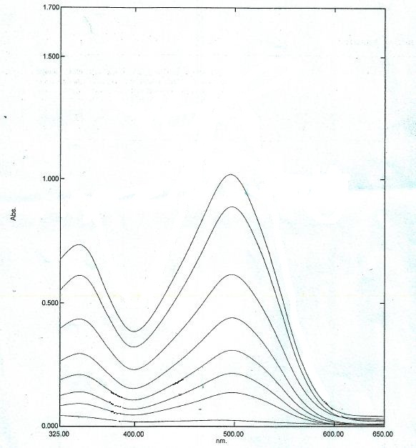

**25ppm**

**15ppm**

**20ppm**

**10ppm**

**7ppm**

**5ppm**

**3ppm**

**1ppm**

**Figure-9- UV-visible spectrum of Congo red.**

It is obvious from figure-9- that the concentrations that obeyed the Lambert-Beer's law were (1 ppm – 25 ppm) that were prepared by the dilution equation:

**ppm1* V1 (ml) = ppm2 * V2 (ml) ………..(7)**

The accuracy of the calibration curve (R2= 0.9952) and it was very high. From figure(3-19) it can be concluded that the λmax= 497nm and it agrees with Movahedi M., et. al. (2009), Tišma M. et, al. (2012). And can convert the absorbance to concentration from the Lambert-Beer's law Skoog D. et. al. (2004), Christian G. D., (2004) &Harvey D., (2000):

***A* = *ƐbC* …….(8)**

*A=Absorbance*.

*Ɛ= molar absorptivity=* ***slope****= 0.044 cm-1.mole-1.litre from the calibration curve.*

*b= the cell thickness and usually= 1 cm.*

*C= the concentration of the substance.*

***C= A/slope= A/0.044 ………(9)***

**Examination of the photocatalytic activity of the prepared photocatalysts**

The photocatalytic activity for the prepared photocatalysts Ag2O/Cr2O3 was determined by the removal percentages as in figure-10-:



**Figure-10-: Photocatalytic activity of the prepared Ag2O/Cr2O3.**

The best photocatalytic activity catalyst was determined from the above figure and table and it was (69.35%) for the sample Cat-3C- that it ratio was (40:60)% of (Ag2O:Cr2O3) and which was calcinated at (400oC), because it gives smaller band gap to transfer more electron for the increase of the photoreaction and decreasing of the electron/hole recombination, and also because the small mean crystallite size (**17.01 nm**) of Cat-3C- that was increased the surface area that will increase number of active site on the surface of the photocatalyst which upon it the adsorption process was proceeded.

**Determination of the adsorption time:**

This process is to determine the time that all the dye molecule placed in the active sites and all the active sites are all full, to increase the photocatalytic efficiency by increasing number of degraded molecules of Congo red figure -11-.



**Figure-11-: The determining of the adsorption time of the photocatalyst Ag2O/Cr2O3 (Cat-3C-).**

It was investigated that the adsorption time of Ag2O/Cr2O3 becomes constant when the time of the adsorption reaction reached (40 minutes) then the adsorption reaction was at an equilibrium state where there was no empty active sites to adsorb the molecules of the dye on the surface of the photocatalyst so the reading of the concentration became approximately fixed.

**Effect of the catalyst's weight:**

It was notified that the concentration of Congo red approach to zero for each weight of catalyst after (60minutes) of irradiation time and the linear equation relation with the irradiation time and from figure-12- it was notified that the rate of photoreaction increases with increasing the weight of the catalyst in the photoreaction's mixture until reached the tip of the plateau at (0.07 g) and then the rate of photoreaction began decreasing gradually with the increase in the weight of the photocatalyst, where the rate of photoreaction at the plateau region was (0.044 min-1) as the most rate of photoreaction.

The increasing in the weight of catalyst increases the number active sites available for the adsorption process on the surface of the photocatalyst which increases the number of adsorbed molecules of the dye on the surface of the photocatalyst which increases the number of utilized photons of the incident light and also increase of releasing the number of •OH and O2•− radicals then the rate of degradation increased, this increment continues until reach the tip of the plateau or the optimum catalyst's mass, then the reaction rate began decreasing with the increase in the weight of the photocatalyst because of the accumulation of an excess number of the photocatalyst's particles(number of adsorbed dye not sufficient to fill the active sites of Ag2O/Cr2O3) which might reduce the transmitted incident UV-light through the solution, so the number of degraded molecules will be decreased then the measured concentration of the dye will be high that which decreases the reaction rate, in general the photocatalytic efficiency depends on the equilibrium between the number of utilized photons and the number of active sites on the surface of the semiconductor, then the excess additional amount of the photocatalyst does not enhance the photocatalytic process [Jain R., te. al. (2006), Ameta P.et. al. (2007), Meena R. C. et. al. (2009)].

**Figure-12-: Effect of mass of catalyst on the photocatalytic degradation of Congo red, concentration of the dye is (10 ppm) with different weights of Cat-3C- of Ag2O/Cr2O3 at pH=7 at temperature (298.15 K) with light intensity (7.1 mW/cm2).**

**Effect of the initial concentration of Congo red:**

The results listed in indicate that the decomposition rate of the dye depends on the initial concentration of the dye, so when increase of the irradiation time the remaining concentration (Ct/Co) of Congo red will be decreased at using of Ag2O/Cr2O3 (Cat-3C-) with a weight (0.07 g), but it increases with increasing the taken initial concentration of Congo red from an experiment to another, that means the increase in the initial concentration of the dye decreases the rate of reaction as in figure-13-, when the concentration of the Congo red was (10 ppm) the reaction rate was (0.044 min-1), but when the concentration of Congo red was (25 ppm) the reaction rate was reduced to (0.004 min-1) that is absolutely slower than that of concentration of (10 ppm), this behavior due to that when the molecules of the dye adsorbed on the surface of the photocatalyst the active sites of the photocatalyst it all will be occupied by the adsorbed molecules of dye, but after the addition of an excess number of dye molecules it will be accumulated on the first adsorbed layer of molecules made another layer which is not adsorbed molecules that which affect the utilization of the incident light on the surface and the transmitted light will be reduced because it was well blocked by the accumulated layers of the excess concentration of the Congo red [Borhade A. V. et. al. (2012), Samira S. et. al. (2012), Phoacharern, (2006), and Konstantinou I. K. et. al. (2004)].

**Figure-13-: Effect of concentration of Congo red on the photocatalytic efficiency, weights of Cat-3C- of Ag2O-Cr2O3 was (0.07g) at pH=7 at temperature (298.15 K) with light intensity (7.1 mW/cm2).**

**Conclusion:**

Ag2O/Cr2O3 was successfully prepared and characterized by XRD and SEM and with average mean crystallite size **17.01** nm, the best Ag2O/Cr2O3 prepared catalyst in the photoactivity was (Cat-3C-) with percentage (40:60) calcinated at 400oC. From the results we can conclude that the optimum mass of catalyst for Ag2O/Cr2O3 was 0.07g for degradation of Congo red that its concentration was 10ppm at 25oC and 7.1 (mW/cm2) light intensity.

**Acknowledgment:**

First of all, I would like to express my great appreciation to my Allah for support that enables me to complete this work. After Allah mercy, grateful thanks go to the prophet Mohammed and Ahlu-Albayat (Peace of Allah be upon them).

Special thanks are due to my supervisor, Assist. Prof. Dr. Nada Yahya Fairoz for her great suggestion of my subject name and for her irreplaceable suggestions, wonderful contributions, and continuing support in starting and completing this scientific research.

I would like to express my deep and special thanks to my parents, wife, sister and brothers. I wish to thank Babylon University, the Faculty of science, and the Department of Chemistry for offering me the scholarship and related facilities.

**References:**

1. Ameta P., Kumar A., Paliwal M., Ameta R. and Malkani R. K., (2007), Photocatalytic Bleaching of Rose Bengal by Some Coloured Semiconducting Oxides, *Bulletin of the Catalysis Society of India*, **Vol.** 6, pp.130-135.
2. Bibek, D. (2010). Competitive Adsorption of dyes (congo red, methylene blue, malachite green) on Activated Carbon, *National Institute of Technology, Rourkela*.
3. Borhade A. V., Tope D. R., and Uphade B. K., (2012), An Efficient Photocatalytic Degradation of Methyl Blue Dye by Using Synthesized PbO Nanoparticles, *E-Journal of Chemistry*, **Vol.** 9,No. 2, pp. 705-715.
4. Cheng C. K., Azrina Abd A., Shaliza I., Manickam M. and Pichiah S., (2012),. Heterogeneous Photocatalytic Oxidation an Effective Tool for Wastewater Treatment–A Review, *Department of Civil Engineering, Faculty of Engineering, University of Malaya, Department of Chemical Engineering, National Institute of Technology Tiruchirappalli, Malaysia India.*
5. Chia-H. Li, Yung-H. H., Wan-T. C., Chin-C. L. and Chao-L. K., (2007), Study on preparation and photocatalytic performance of Ag/TiO2 and Pt/TiO2 photocatalysts, *Separation and Purification Technology*, Vol.58, pp.148–151.
6. Christian G. D., (2004), Book of Analytical Chemistry, 6th(Ed.), *John Wiley & Sons*, *Inc*., ISBN 0-471-45162-2.
7. Dingwang C. and Ajay K. R. (2001), Removal of toxic metal ions from wastewater by semiconductor Photocatalysis, *Chemical Engineering Science*, Vol.56, pp.1561-1570.
8. Falah H. H., (2011), Photochemical Treatments of Textile Industries Wastewater, *Chemistry Department, College of Science, Babylon University, Iraq,* *inTech.*
9. Galvez, J. B. and Rodriguez, S. M., (2003). "Solar Detoxification", *Plataforma Solar de Almeria*, Spain.
10. Gyawalia G., Adhikaria R., Joshia Bh., Kima T. H., Rodríguez-Gonzálezb V., Lee S. W., (2013)"Sonochemical synthesis of solar-light-driven Ag◦-PbMoO4 photocatalyst", *Journal of Hazardous Materials*, **Vol.** 263P, pp. 45– 51.
11. Harikumar, PS; Litty J.; and Dhanya A., (2013). Photocatalytic degradation of textile dyes by hydrogel supported titanium dioxide nanoparticles, *Journal of Environmental Engineering & Ecological Science,* 2050-1323-2-2.
12. Harvey D., (2000), Modern Analytical Chemistry, 1st(Ed.), *McGraw-Hill Higher Education*, ISBN 0–07–116953–9,.
13. Heponiemi, A. and Lassi, U.(2012) "Advanced Oxidation Processes in Food Industry Wastewater Treatment – A Review", ISBN 978-953-307-905-9, *InTech*.
14. Herrmann, J.-M., (1999). Heterogeneous photocatalysis: fundamentals and applications to the removal of various types of aqueous pollutants, *Catalysis Today*, 0920-5861,Vol. 53, pp. 115-129.
15. Lee, M. (2008). Degradation of Dyes Using Zinc Oxide as The Photocatalyst, Thesis, UNIVERSITI PUTRA MALAYSIA**.**
16. Jain R., and Sikarwar S., (2006), Photocatalytic and adsorption studies on the removal of dye Congo red from wastewater, *Int. J. Environment and Pollution,* **Vol.** 27, Nos. 1/2/3.
17. Julian B. G., and Sixto M. R. (2003), Solar Detoxification, *Plataforma Solar de Almeria, Spain*, United Nations Educational, Scientific and Cultural Organization.
18. Konstantinou I. K. and Albanis T. A., (2004), TiO2-assisted photocatalytic degradation of azo dyes in aqueous solution: kinetic and mechanistic investigations A review, *Applied Catalysis B: Environmental*, **Vol.** 49, pp. 1–14.
19. Lee, M. (2008). Degradation of Dyes Using Zinc Oxide as The Photocatalyst, Thesis, UNIVERSITI PUTRA MALAYSIA**.**
20. Lin X., Wu K., Shao L., Shui M., Jiang X., Wang D., Long N., Ren Y., Shu J., "Facile preparation of Cr2O3@Ag2O composite as high performance lithium storage material", *Journal of Alloys and Compounds*, **Vol.** 598, pp. 68–72 (2014).
21. Lomoră M., Drăghici C., and Eneşca Al., (2011), Intermediary Compounds in Advanced Oxidation Processes for Wastewater Treatment, *Bulletin of the Transilvania University of Braşov*, Vol. 4 (53) No. 1.
22. Meena R. C. and Pachwarya R. B., (2009), Photocatalytic degradation of model textile wastewater using methylene blue immobilized resin dowex-11, *Journal of Scientific & Industrial Research,* **Vol.** 68, pp. 730-734.
23. Miguel, R. (2003). Fenton and UV-vis based advanced oxidation processes in wastewater treatment: Degradation, mineralization and biodegradability enhancement, UNIVERSITAT DE BARCELONA.
24. Movahedi M., Mahjoub A.R. and Janitabar-Darzi S., (2009), Photodegradation of Congo Red in Aqueous Solution on ZnO as an Alternative Catalyst to TiO2", *Journal of Iranian Chemistry Society,* **Vol.** 6, No. 3, pp. 570-577.
25. Nicholas T. N., (2010). Sol-Gel Synthesis and Characterization of Novel Metal Oxide Nanomaterials for Photocatalytic Applications, Doctoral thesis, *Dublin Institute of Technology*.
26. Phoacharern P., (2006), Photocatalytic Degradation of Trypan Blue Using Gold/Titanium Dioxide, *M.Sc. thesis of Science (Chemistry),*Graduate School, Kasetsart University, ISBN 974-16-1885-9.
27. Pooja M. and Jyotsna K., (2013), Degradation of Congo Red Dye in Aqueous Solution by Using Phytoremediation Potential of *Chara Vulgaris, Chitkara, Chemistry Review* Vol. 1, pp. 67–75.
28. Prasad R. and Rattan G., (2010) Preparation Methods and Applications of CuO-CeO2 Catalysts: A Short Review, *Bulletin of Chemical Reaction Engineering & Catalysis,* **Vol.** 5 (1), pp. 7 – 30.
29. Radwan A. Al-Rasheed, (2005), Water Treatment By Heterogeneous Photocatalysis an Overview, *Saline Water Desalination Research Institute*.
30. Riahi-Noori N., Sarraf-Mamoory R. and Mehdikhani A., (2011),Synthesis of Combined ZnO/Additives Nano Powders by Gel Combustion Method for ZnO Varistors Usage, *International Conference on Chemical, Environmental and Biological Sciences* (ICCEBS).
31. Samira S., Raja P. A., Mohan C. and Modak J. M., (2012),Photocatalytic Degradation of Crystal Violet (C.I. Basic Violet 3) on Nano TiO2 Containing Anatase and Rutile Phases (3:1)", *Journal of Thermodynamics & Catalysis*, **Vol.** 3, Issue 5, India.
32. Santhia K., Revathya T.A., Narayananb V., Stephena A., (2014)"Dendritic Ag–Fe nanocrystalline alloy synthesized by pulsed electrodeposition and its characterization", *Journal of Applied Surface Science,* **Vol.** 316, pp. 491–496.
33. Sakthivel S., Shankar M.V., Palanichamy M., Banumathi A., Bahnemann D.W. and Murugesan V., (2004), Enhancement of photocatalytic activity by metal deposition: characterisation and photonic efficiency of Pt, Au and Pd deposited on TiO2 catalyst, *Water Research*, Vol.38 3001–3008.
34. Sathish M. (2006), Photocatalytic and Electrochemical Processes for Generation of Hydrogen and Decontamination of Water. Thesis, *Indian Institute of Technology Madras Chennai.*
35. Shahid. Kh. D., Hussain S. Z., Saeed Kh., Khan Y., Arif M. and Ahmed N., (2012), Hydrothermal synthesis and characterization of nanosized transition metal chromite spinels, *Turk. J. Chem. (T¨UB˙ITAK),* **Vol.** 36, pp. 111–120.
36. Skoog D. A., West D. M., Holler F. J., and Crouch S. R., (2004), Fundamentals of Analytical Chemistry", 8th (Ed.), *Thomson Brooks/Cole*.
37. Suñol J.J., and Escoda L., (2007) "SEM and TEM studies in alloys developed by mechanical alloying", *Modern Research and Educational Topics in Microscopy*.
38. Tišma M., Komar M., Rajić M., Pavlović H. and Zelić B., (2012), Decolorization of Dyes by *Aspergillus Ochraceus* Cultivated Under Solid State Fermentationon Sugar Beet Waste, *Chemical Engineering Transactions(CEt) ,* *The Italian Association of Chemical Engineering,* ISSN 1974-9791, ISBN 978-88-95608-18-1, **Vol***.* 27, pp. 145-150.
39. Vincenzo A., Claudio B., Alessandra B. P., Elisa G. L., Vittorio L., Sixto M., Giuseppe M., Leonardo P., Marco P. and Edmondo P., (2002), Azo-dyes photocatalytic degradation in aqueous suspension of TiO2 under solar irradiation, *Chemosphere* Vol. 49, pp. 1223–1230.
40. Zhang L., Kuhn M. and Diebold U., (1997), Growth, structure and thermal properties of chromium oxide films on Pt(111), *Journal of surface science,* 375, pp.1-12.
41. Zorica. V. M., Sreckovic T. V., Prelevic I. P. and Ristic M. M. (2002), Structural Changes of ZnO-Cr2O3 System during Mechanical Activation and Their Influence on the Spinel Synthesis, Belgrade, Yugoslavia, **Vol.** 10, pp.155-160.